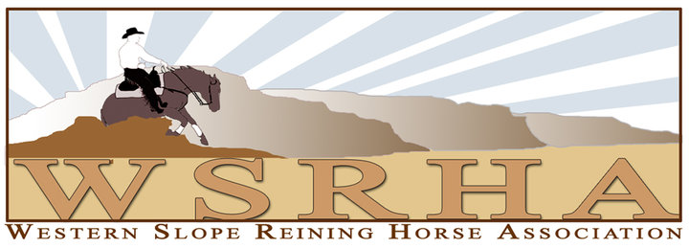
CLUB CHAMPIONSHIP AWARDS

It is the goal of the western Slope Reining Horse Association (“WSRHA”) to promote reining at every level. The Club Championship year-end series awards our members for points earned in each of the following WSRHA Club Classes:

Rookie I & II | Intermediate Non Pro | Novice Horse Open I & II | Short Stirrup
Prime Time Rookie | Limited Non Pro | Rookie Professional | Youth 13 & Under
 | Non Pro | Limited Open | Youth 14 – 18
 | Prime Time Non Pro | Intermediate Open | Youth Rookie
 | Novice Horse Non Pro I & II | Open
 | Masters Non Pro

All exhibitors and owners must be current members of the Western Slope Reining Horse Association and in good standing for the current year in order to qualify for year-end awards. NRHA Competition License will be used to show proof of ownership. If the horse does not have an NRHA Competition License, breed registration papers will be used. Ownership is not required for Green as Grass, Rookie and Youth Club Classes.
NRHA membership is NOT REQUIRED in order to be eligible for the WSRHA Club Class Championships.
WSRHA membership IS REQUIRED in order to be required for year end awards.

POINT SYSTEM
- Points are awarded in each class based on the NRHA youth point scale as outlined in the current NRHA Rulebook.
- All year-end awards are calculated using the total points earned in all of the WSRHA shows entered in the current year.
- In the case of class ties at each show, the points awarded for those places are combined and divided by the number of entries tied. Decimal places are calculated to the nearest two places.
- A score of 0 (zero) or a No Score will NOT be awarded points for that class but will be considered as competing in that class at that show.
TIEBREAKER RULES
- The Tiebreaker rules are used to determine all Year-End and Reserve Championships.
- First Tiebreaker: The entry with the most wins per designated class wins that class award.
- Second Tiebreaker: The entry with the highest class scores wins that class award.
- Final Tiebreaker: A flip of the coin by the WSRHA Board of Directors
- Eligibility of riders and/or horses is determined based on their records accumulated prior to January 1st of the current year.
- Both riders and recorded owners must be members in good standing with WSRHA prior to entering the classes for points to count. If a horse is owned by an “entity”, e.g., an LLC. partnership, corporation, syndication, etc., the entity must have a WSRHA membership in order for the horse to qualify for any year-end awards. Individuals of that entry are not required to have individual memberships, unless that individual competes on the “entity” owned horse and wishes to have the points earned count toward the year-end standings.
- In order to be eligible for the WSRHA Year-End Awards, same horse/same rider must compete in two of the WSRHA Club Championship Shows in that particular class. Points from all shows are totaled to determine the winners. A substitution from either the horse or the rider is not allowed under any circumstance.
- NRHA rules will apply to all riders and horses for the purpose of eligibility to enter each class. It will be the obligation of each member to insure his or her eligibility and their horse’s eligibility.
- The WSRHA Board of Directors utilizing these Rules and Regulations and any other information available to them from the NRHA and any other equine organizations will settle complaints or protests regarding class or award eligibility. All decisions by the WSRHA Board of Directors are final.

